**Register:**

* register is used to store the response after execution of any task

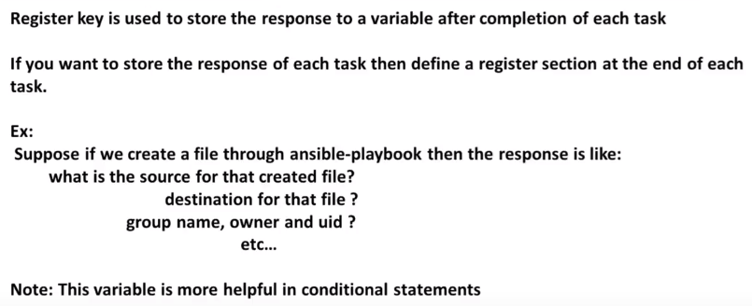

* As below, we are creating a file and to catch that response after task, we are using register module. We can take any module name but make sure we are not using any module name or key for the register module
* Now to print that in command line, we use debug mode

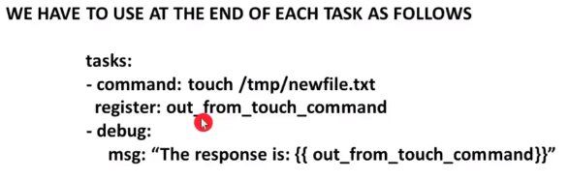

**Example**:

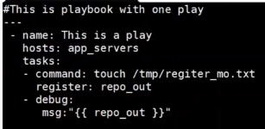

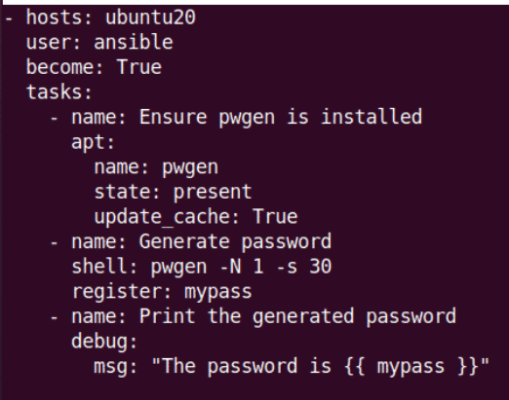

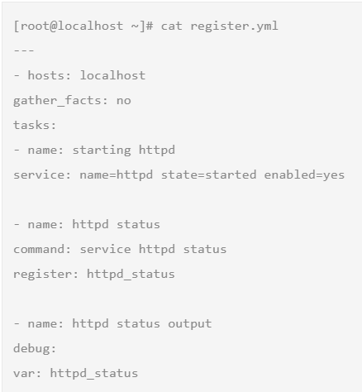

**Debug:**

* With the debug, we can print the message or add the variables as below.

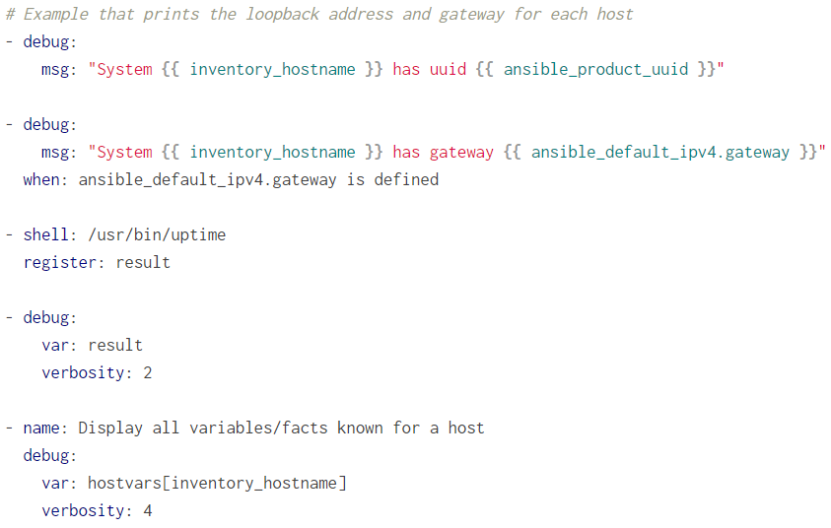

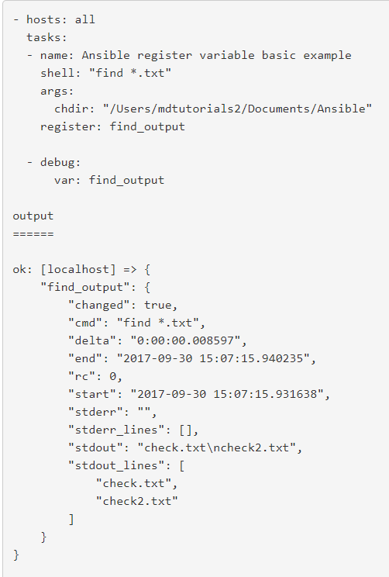

**Examples:**

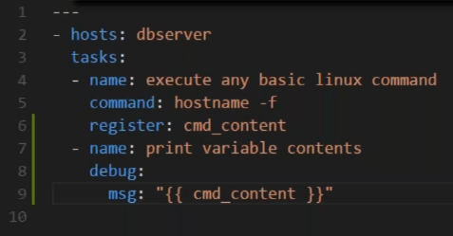

* After running this, we can see the details, stderr is where we can see if any error occurs and stdout is the machine name

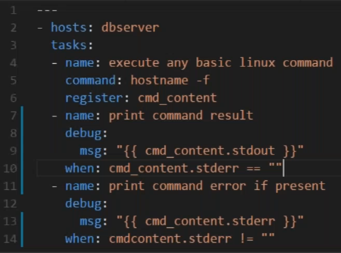

* As above, it prints the data when cmd_content.stdout when stderr is empty and also it prints cmd_content.stderr when stderr has something which is not equals to empty
* We can also add below. They are facts mentioned in below image

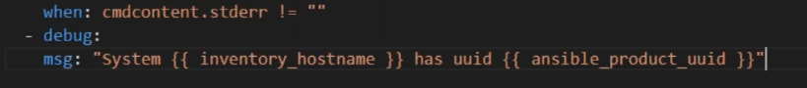

* Double curly braces used for facts and our own created variables
* When we are using registry. It is called variable
* In msg, we use curly braces but in when we no need to use it because it automatically expands the variable
* After running the yml file, we can see the task skipping as there is no error in that

 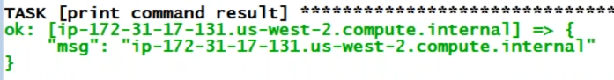

* Wrong command error won’t get capture in stderr because it is a syntax error

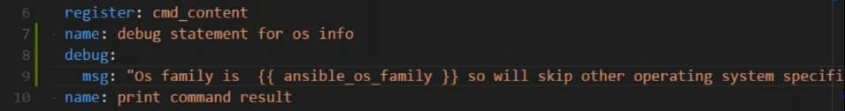

* After using the above, we will get below result

